

**Bonus Project: School Donation Analysis**

Contents

**Note:** 3

**1. Create a file based data set** 4

**2. Basic editing of data set columns (2:04)** 5

**3. Overview of data distribution (3:40)** 7

**4. Simple Analysis and Calculations (5:41)** 11

**5. Simple Trending Analysis (7:51)** 13

**6. Visualization Trellis and basic filters (10:06)** 17

**7. Basic Viz formatting, coloring (11:40)** 19

**8. Cross Viz interactions: Brushing, Use a Filter (14:34)** 22

**9. Basic Forecast and Reference Lines (15:48)** 24

**10. Metrics Binning (20:08)** 28

**12. Mashing-up & joining additional data (24:41)** 33

**13. Viz Specific Aggregations (27:03)** 35

# **Note:**

This is an optional lab, based on “**Oracle DV Workshop - Simple Visual Analysis Of Data With Oracle DV**” demo. <https://www.youtube.com/watch?v=8DaYTlwkBmg&list=PL6gBNP-Fr8KXmHU_qvgq9EANchxvzz-zZ&index=1>

This document contains basic notes, assumes that you have completed “**Assignment 2: Building Your First Data Visualization Project with Oracle Analytics**” so you just need an additional practice on your own.

Solution **School Donation Analysis.dva** project available to download under solution area, to import into your Data Visualization environment.

* This workshop uses these two xlsx files to showcase Data Visualization capabilities
  + The **Donation** dataset has 150k rows of Schools Projects Donations information spread across 5 years
  + The **Zip_Stats** dataset has ~32k rows of Income and Population information at US ZIP codes level

# **1. Create a file based data set**

- Navigate to the .xlsx file for this workshop

Let's upload the **Donation_Example.xls** file and create a dataset.

Give it a bit of time to upload the dataset...

- Open

# **2. Basic editing of data set columns (2:04)**

- Once data is loaded, column properties can already be edited before creation of the data set

- Change to **Attribute**:

* **SCH_LONGITUDE**
* **SCH_LATITUDE**

Let’s now Ad the Data set

Each Data Set uploaded is automatically profiled to recognize data and recommend preparation steps.

Based on the data discovery, a set of recommendations for transformation and enrichments are suggested.

Two transformations are suggested for SCH_STATEZIP: to split State and ZIP codes into two separate columns. Let's apply both one by one.

Every transformation we choose to include gets added into the Preparation Script pane as a step.

**SCH_STATEZIP**

> **Rename** SCH_STATEZIP_Part 1 to **SCH_STATE**

Add the second transformation for **SCH_STATEZIP**

> **Rename** SCH_STATEZIP_Part2 to **SCH_ZIP**

Let’s hide the initial concatenated column now.

Options menu offers various single-click transformations for each type of column (metrics, attributes, dates)

Data types, aggregation rules and default formats can easily be changed

> **STUDENTS_REACHED** > General > Aggregation to **Average**

> **TOTAL_DONATION** > Number Format > **Currency** / Abbreviate **On**

**DATE_COMPLETED** was recognized as a Date type column, but **DATE_POSTED** was not, due to its format. Let's convert it

> select **DATE_POSTED** > Options > Convert to date **dd.MMM.yyyy**

> Add Step

Click on Apply Script button to apply all the steps in the sequence that they appear in the Preparation Script

**> Apply Script**

Now that New **DATE_POSTED** is of date type, let's assign it a default Format **23-Jan-17**

Let’s now create a Project with this Data Set

**> Create Project**

# **3. Overview of data distribution (3:40)**

Explain feature generates insights for attributes and measure columns to analyze important and non-obvious patterns in data.

> Select **RESOURCE_TYPE** attribute from Data Elements Pane > Right Click > **Explain** **RESOURCE_TYPE**

For **attribute** columns **Explain** generates **Basic Fact insights** (distribution across categories)

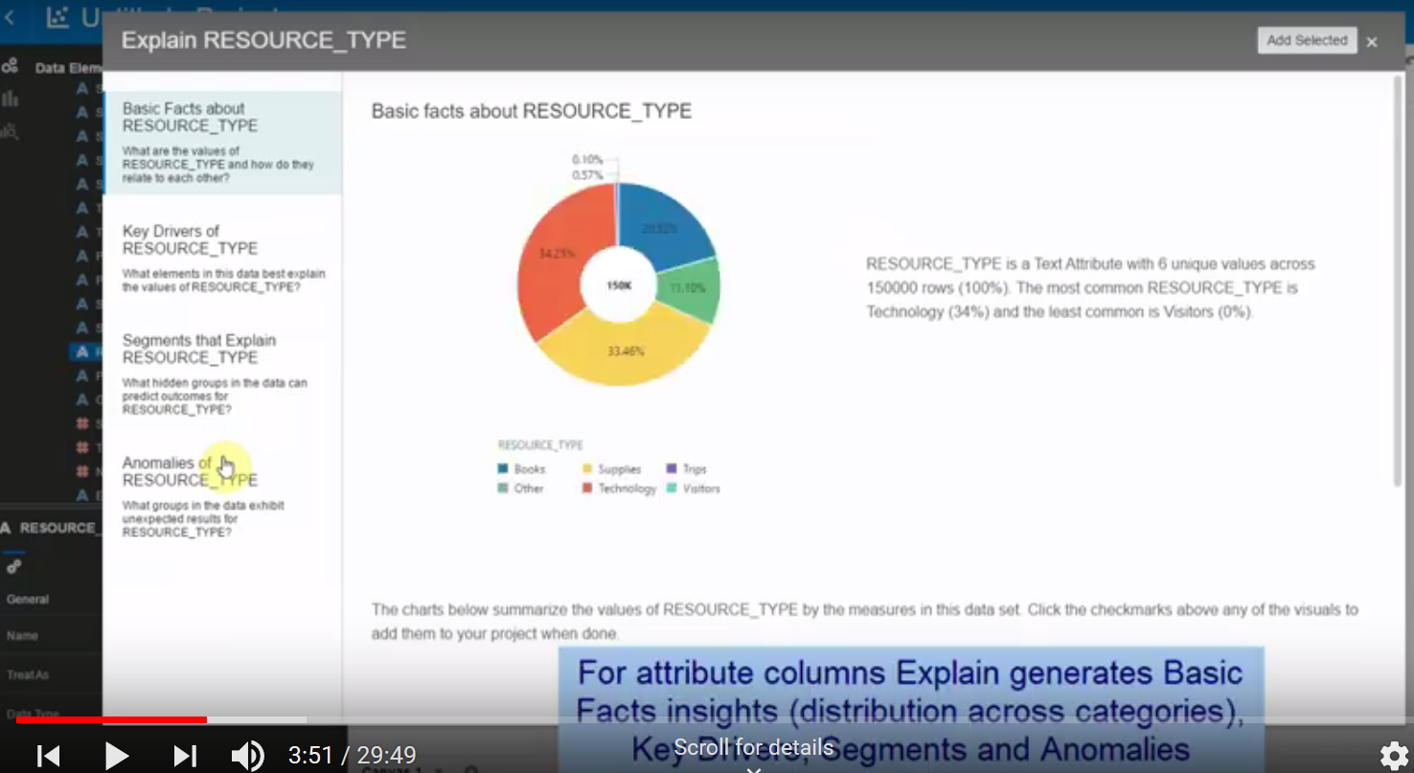

Key Drivers list columns that influence attribute values and their distribution

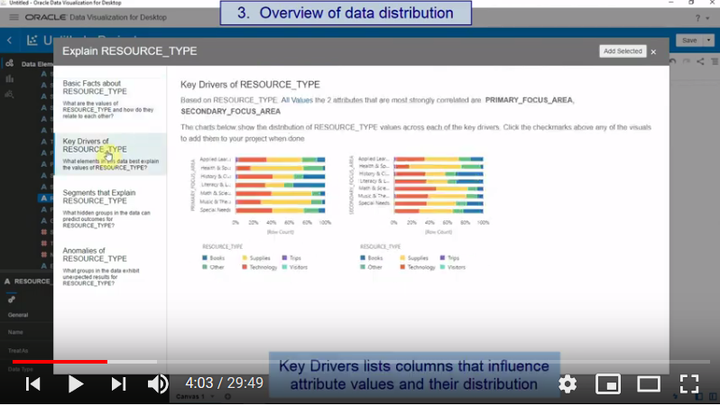

Segment tab visualizes segments where value for the attribute can be identified with certain confidence based on other columns in the dataset

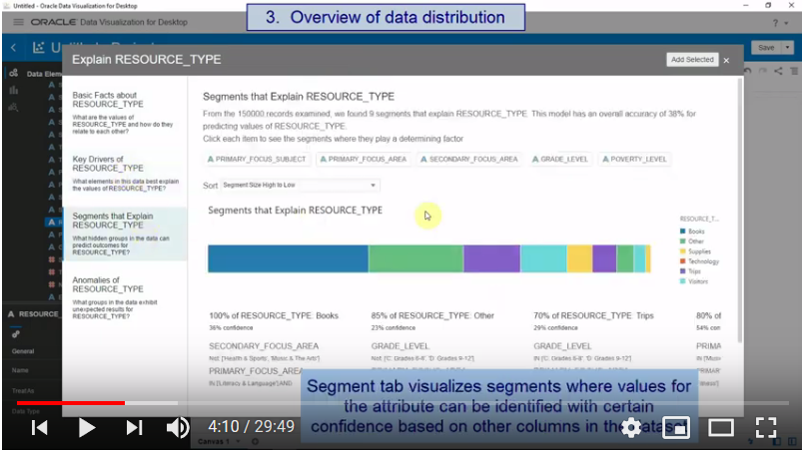

Anomalies tab performs combinatorial analysis between selected attribute and other attribute columns and shows groups that exhibit unexpected behavior.

> Select **TOTAL_DONATIONS** attribute from Data Elements Pane > Right Click > **Explain** **TOTAL_DONATIONS**

For metric columns Explain provides Basic Facts and Anomalies insights based on the aggregation rule.

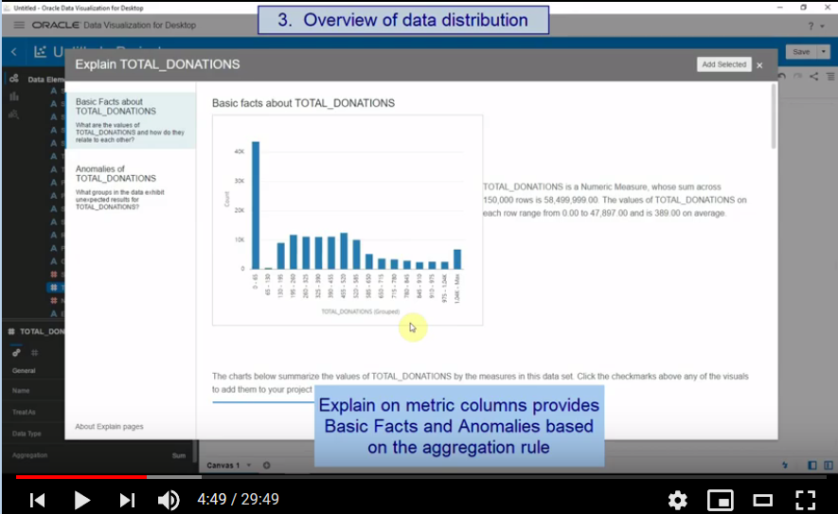

Insights/Visualizations of interest can be marked and added directly to DV canvas.

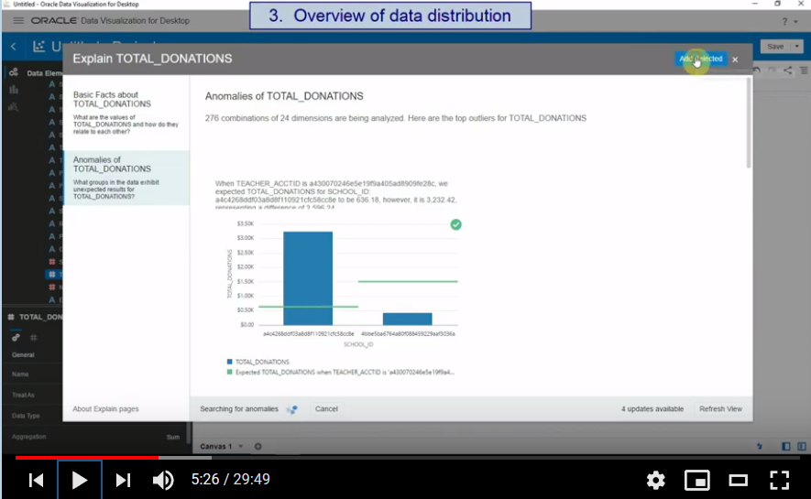

* Add Insights

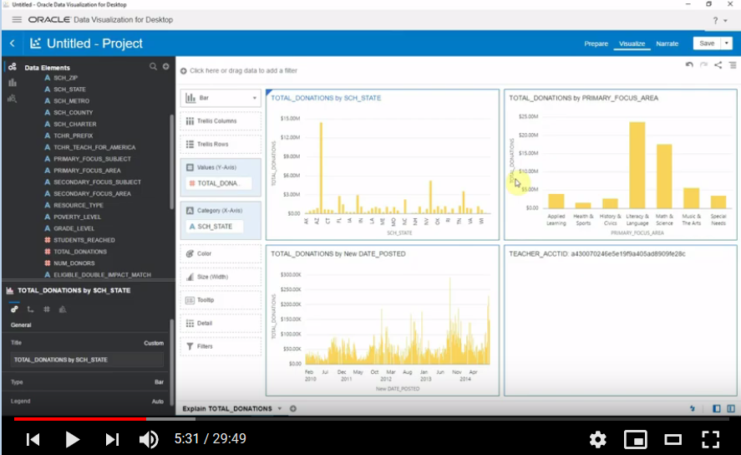

* Clear Canvas

Let’s further analyze the data now

# **4. Simple Analysis and Calculations (5:41)**

**Visualize Pane**

Properties pane is still visible with type, default agg rules and format for each column

Let's first get a few totals on this data set

> **PROJECTID** change to **Measure** (Text / Count) > **Tile**

> **TOTAL DONATTIONS** > **Tile**

We can set agg rules on Attributes as we need it

**SCHOOL_ID** change to **Measure** (Text, CountDistinct) > **Tile**

Then **Delete Visual** and change again to **SCHOOL_ID (Attribute / Text)**

Aggregations can be set at the column level, or also be done in custom calculation column

>**My Calculations** > right click **Add Calculation**

**# of Schools** COUNT(DISTINCT SCHOOL_ID)

> **# of Schools** > **Tile**

Adding custom calculations and ratios is very simple

> **My Calculations** > right click **Add Calculation**

**Avg $ per Project** TOTAL_DONATION/PROJECTID

> **Avg $ per Project** > **Tile**

Let's create a custom calculation that is based on another custom calculation

> **My Calculations** > right click Add Calculation

**Avg $ per School** TOTAL_DONATION/(COUNT(DISTINCT SCHOOLID))

> Avg $ per School > **Tile**

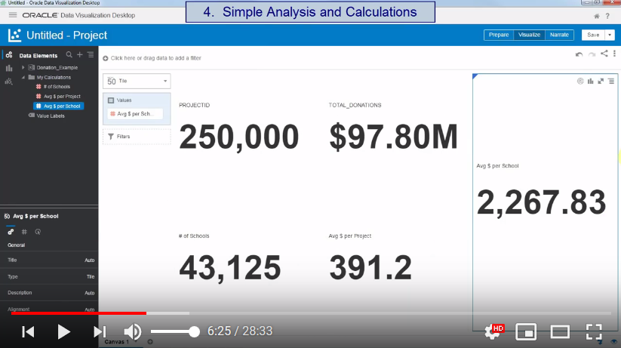

Then **Delete** vis **Avg $ per School**

# **5. Simple Trending Analysis (7:51)**

Let's now look at these metrics and calculations over time

> Select **TOTAL_DONATION**, **DATE_POSTED** > **Best Visualization**

> **Rearrange Visualizations**

Looking at it by day is too detailed, we need weeks or months time grain

> go to Category (X-Axis) **DATE_POSTED** > Show By > Week

Changing **Chart Type** is a click away

> Change from **Line to Bar**

> Undo

>> go to **Category (X-Axis)** **DATE_POSTED** > Show By > **Month**

Let's add our calculated column to that timeline chart

> Drag and drop **Avg $ per Project** to Values **(Y-Axis)**

> Change to **Y2 Axis**

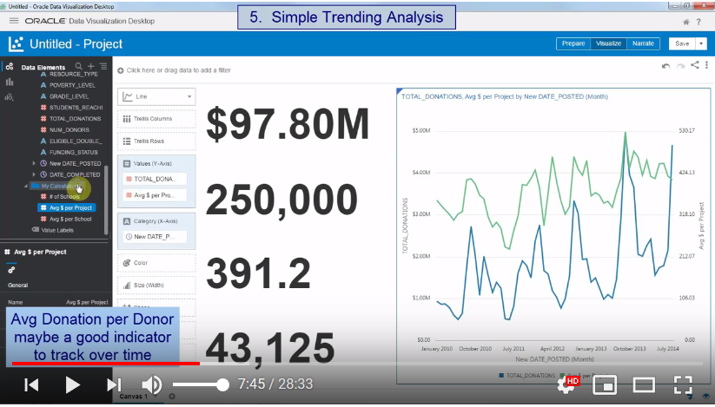

Avg Donation per Donor maybe a good indicator to track over time

> Add Calculation **Avg $ per Donor** = TOTAL_DONATION/NUM_DONORS

> Drag and drop **Avg $ per Donor** to Values (Y-Axis)

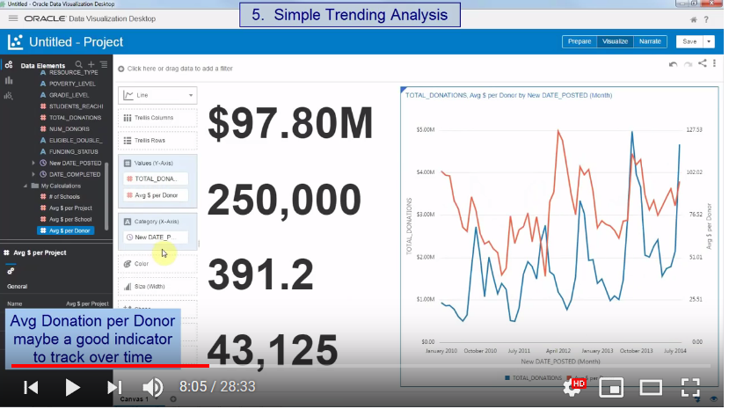

Avg Donation per Donor may be a good indicator to track over time.

Let's add calculated trendlines to compare overall trend

> **Add Trendline**

> Change

Confidence Intervals to **Off**

Method to **Polynomial**

Degree to 3

Method to **Exponential**

>**Delete # of Schools vis**

> Go to PROJECTID Vis and change Title to Custom # of Projects

> **Save the project**

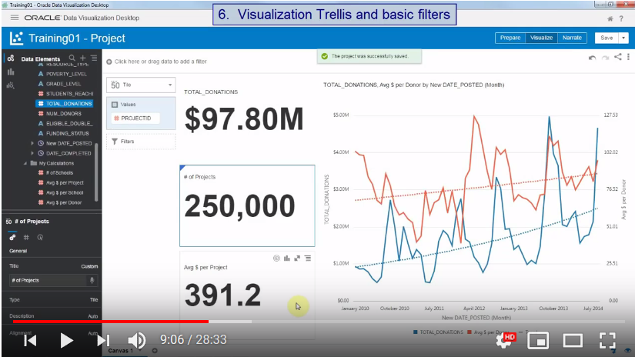

# **6. Visualization Trellis and basic filters (10:06)**

Let's now copy this trending viz to leverage it further into a different canvas

> **Copy Viz TOTAL_DONATION**, **Avg $ per Donor by** **DATE_POSTED (Month)**

> **New Canvas**

> **Paste Viz**

Let's slice this viz on several dimensions using trellis grammar

> Drag and drop **POVERTY_LEVEL** to **Trellis Columns**

**Changing Line Type** or hiding lines make it clear

> Go to **General > Line Type > Stepped**

> Go to **General > Line Type** > **None**

Now let's **Add** one more **Dimension** to compare trends

> Drag and drop **SCH_METRO** to **Trellis Rows**

Let's **Filter** out the **NULL** value in the Metro column

> **SCH_METRO** Create Filter > Selections **> Exclude Selections NULL**

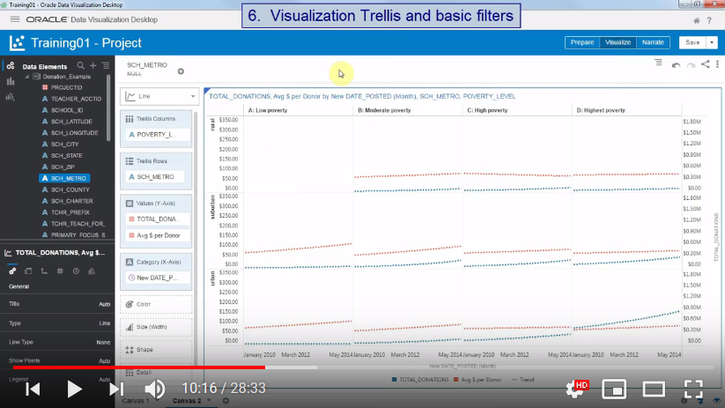

# **7. Basic Viz formatting, coloring (11:40)**

> **New Canvas**

Let's filter a few visuals on this new canvas, involving several dimensions

> **Paste** Vis **TOTAL_DONATIONS Avg $ per Donor by DATE_POSTED (Month)**

> Select ***PROJECT_ID*, PRIMARY_FOCUS_AREA, RESOURCE_TYPE**

> Pick Vis to **Pivot Table**

> **Rearrange** Vis to Bottom

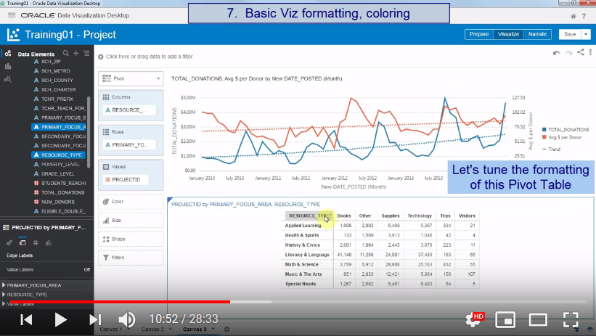

Let's tune the formatting of this Pivot Table PROJECTID by TOTAL_DONATIONS PRIMARY_FOCUS_AREARESOURCE_TYPE

> **Edge Labels** (Second tab) > **Value Labels** to **Off**

> Go to Pivot Table **RESOURCE_TYPE** > **Show Total**

> Drag and Drop **TOTAL_DONATION** to **Color**

Let's show numbers as a percentage of total table

Go to **# Values PROJECTID Display As** **Percent of** **All Values**

Let's bring a simple Geography Visualization

> Select **SCH_STATE, TOTAL_DONATIONS** > Pick Visualization **Map > SCH_STATE, TOTAL_DONATIONS**

> **Duplicate Visual**

Drag and Drop (Replace) **Avg $ per Donor** to **Color** (Map Shape) > **SCH_STATE, Avg $ per Donor**

A few basic formatting tips

> Select **TOTAL_DONATIONS Avg $ per Donor by DATE_POSTED** **(Month)**

**>**  **General** tab > **Legend None**

> Select Vis **SCH_STATE, TOTAL_DONATIONS**

> Right Click > **Color** > Pick Visualization Colors > **Manage Color Assignments**

Colors can be set by metric, by series, for an entire palette, or to highlight individual members

> Select **Avg $ per Donor** > Custom Gradient > Three Color Gradient

Reset Series Color

> Series **Color Palette** > Southwest / **Pastel**

> Select Pivot Table > **Technology** column > **Color >** **Data Point** > change to #fa373

> **Literacy & Language** row > Color > Data Point > ...

**Undo**

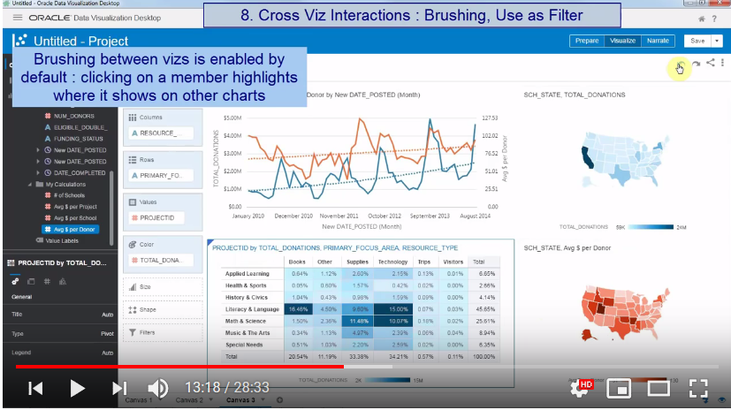

# **8. Cross Viz interactions: Brushing, Use a Filter (14:34)**

Brushing between vizs is enabled by default: clicking on a member highlights where it shows on other charts

* Click on different viz

Visuals can also be used as filters for other visuals on the canvas

> Select viz **SCH_STATE, TOTAL_DONATIONS**

> Use as Filter

> Select TX state

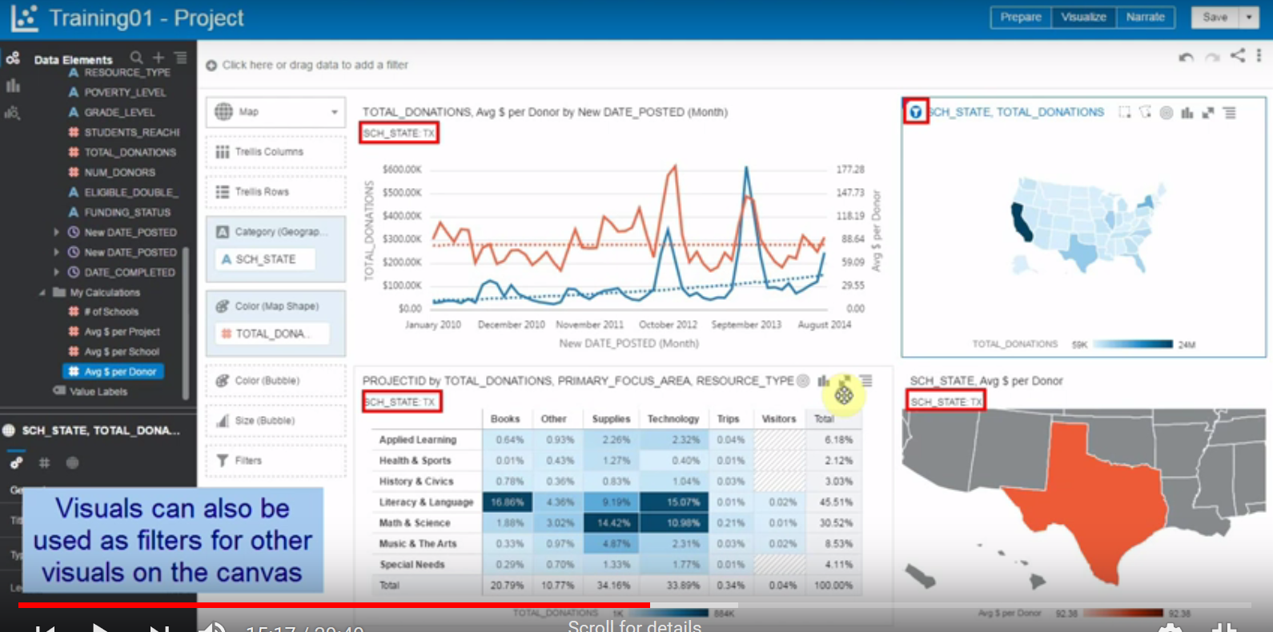

> Select vis **PROJECTID by TOTAL_DONATIONS PRIMARY_FOCUS_AREA RESOURCE_TYPE**

> Right Click > **Use as Filter**

> Select viz **SCH_STATE, TOTAL_DONATIONS**

Select some state

> Right click > **Clear Canvas**

# **9. Basic Forecast and Reference Lines (15:48)**

Let's reuse the timeline chart created earlier and simplify it a bit

> **Paste** Visual **TOTAL_DONATIONS Avg $ per Donor by DATE_POSTED (Month)**

> **Delete** **Avg $ per Donor** from **Values (Y-Axis)**

Right click menu offers several options, let's add some Reference Lines and Bands

> Right click > **Add Reference Line > Analytics > (Average)**

> Right click > **Add Reference Line > Analytics >**

Reference > Method **Median** change to Method **Band**

Function **Standard Deviation**

Let's slice these references analysis by Metro type

> Add **SCH_METRO** to **Trellis Columns**

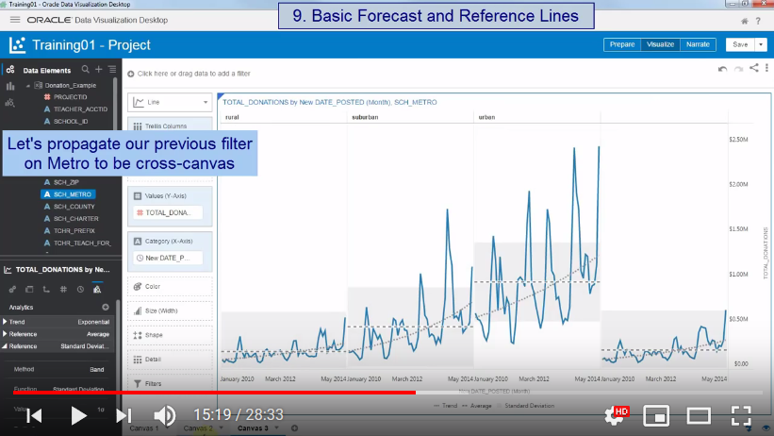

Let's propagate our previous filter on Metro to be cross-canvas

**SCH_METRO** filter > **Pin to all Canvases**

Now let's try the right-click forecast option

**Add Forecast**

It errors out, because we are using a calculated time hier. level (month) out of our Date-Posted (day) column

That month object simply needs to be added in the dataset, a single click extract

**Prepare**

**DATE_POSTED** **> Extract > Month**

The new column is here, we can use it for forecast now

**Visualize**

> Drag and Drop (**Replace**) DATE_POSTED with **DATE_POSTED Month1**

Simple forecast parameter can be edited on Properties Pane

* Analytics > Forecast > Periods > **6**

Viz with forecast columns behave exactly the same as other vizs

> Drag **SCH_METRO** from Trellis Columns to **Color**

> Delete **SCH_METRO**

> **Change Forecast** > **Prediction Interval** to **Off**

>**Disable Filter**

Forecast formulas can also be edited with greater details in custom calculations

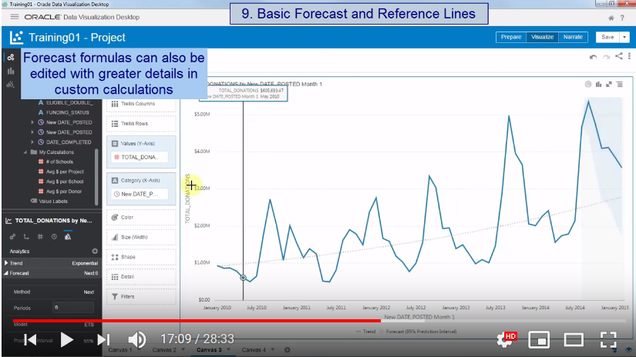

> Add Calculation

**Calculated Fcst** = FORECAST(TOTAL_DONATIONS, (DATE_POSTED), 'forecast', '',6 )

FORECAST(XSA('weblogic'.'Donation_Example')."Columns"."TOTAL_DONATIONS", (XSA('weblogic'.'Donation_Example')."Columns"."DATE_POSTED Month 1"), 'forecast', 'modelType=arima;numPeriods=%1;predictionInterval=70;', 6)

> Select **TOTAL_DONATIONS**, **DATE_POSTED**, **Calculated Fcst** > Pickup **Bar**

> Move **Calculate Fcst** to **Values (Y-Axis)**

> Change to **Stacked Bar**

> Change to **Pivot**

> **Values** > **TOTAL_DONATION** > Number Format **Currency** > Abbreviate **On**

**> Values > Calculated Fcst** > Number Format **Currency** > Abbreviate **On**

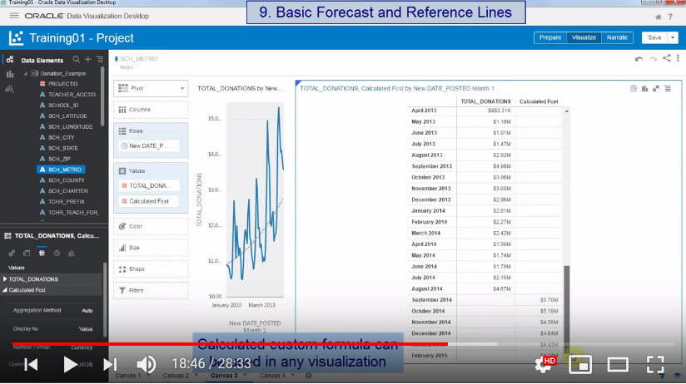

# **10. Metrics Binning (20:08)**

> **New Canvas**

Let's try to bin Donation column values

> Select **TOTAL_DONATION** Pick Visualization > **Bar**

I simply drag the metric into the category (attribute) grammar to generate bins

> Drag and Drop **TOTAL_DONATION** to Category (X-Axis)

Bins can be edited easily

**>** Category (X-Axis) > Right Click > **Edit Group** **10 / 15**

> **Delete filter**

The bins are on **Donation value** **by Project** (the grain of our dataset). Exp, last bin: the bar shows the total donation for all projects that each received $980 or more

Now, let's have bins on Donation Value by School, not by Project.

* Values > Level of Detail > **Group Values >** **SCHOOL_ID**

Now the bins are on Donation value by School. Last bin shows the total donations for all schools that each received $5.6k or more

More metrics can be compared on the bins we just created

> Drag and Drop **# of Schools** to Values (Y-Axis)

Move to **Y2 Axis**

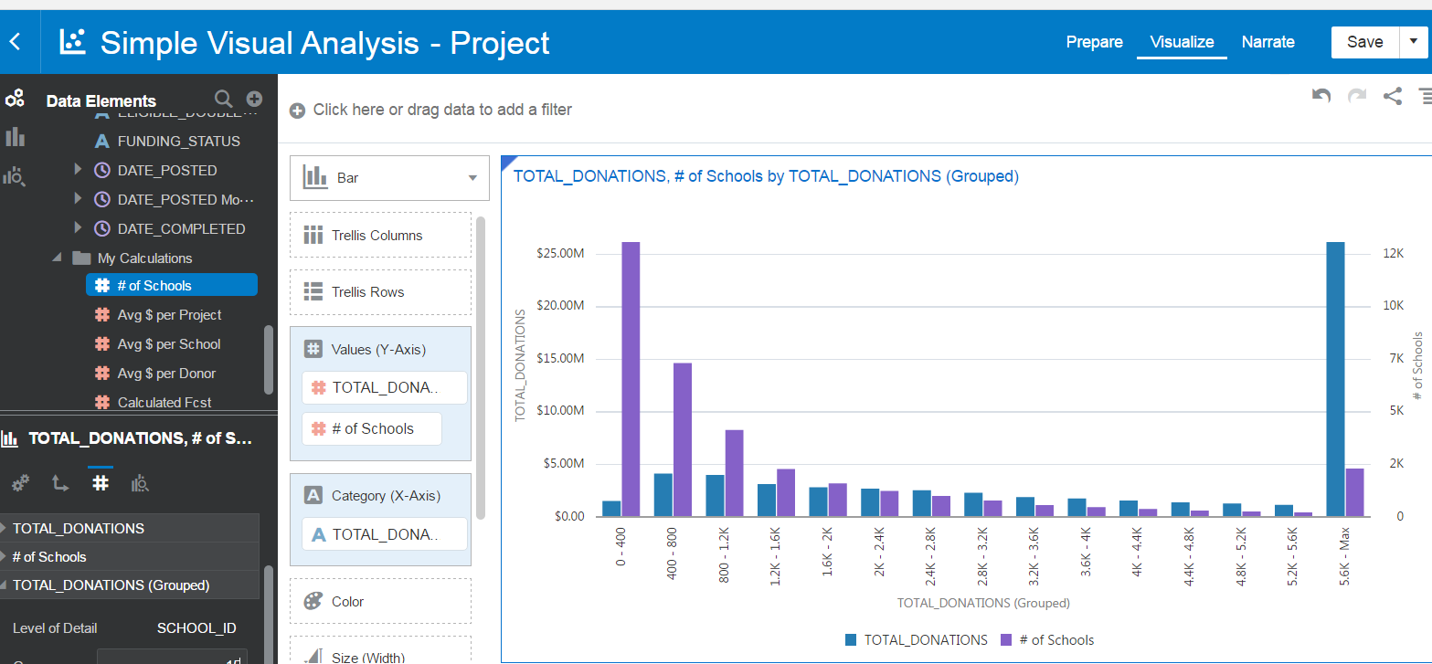

> **Delete # of Schools**

Now let's filter out all the tail end schools that receive more than a certain amount, and see how it impacts the distribution

> Move **TOTAL_DONATION** to **Filter**

Here again, I need to specify what to sum donations by my filter: Schools

> Filter > Range > By **SCHOOL_ID**

> Move cursor to Max 4,230

The same binning, but with plotted projects on the chart excluding schools that received over $9k altogether

* Values > Data Values to **On**

Bins can be defined (and refined or persisted) as custom calculations too. More options are available in this case.

> **Add Calculation**

**Calculated Bin** = BIN(TOTAL_DONATION BY SCHOOLID INTO 15 BINS)

> Select **Calculated Bin**, **TOTAL_DONATION** Pick Visualization **Bar**

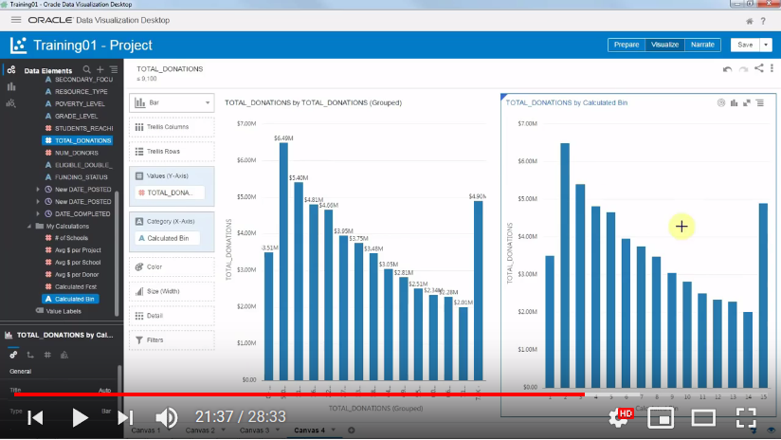

**11. Top Ns Filtering (22:59)**There are thousands of schools in this dataset. Let's represent them in a bar chart.

> Select **SCHOOL_ID, TOTAL_DONATION** > **Best Visualization**

> **Sort** **SCHOOL_ID** by **TOTAL_DONATION High to Low**

> **Change** to **Stacked Bar**

Now, let's keep only the Top Ns on total donations metric

> Drag **TOTAL_DONATION** to **Filter** and change Filter Type **to Bottom N**, Count 50 / **100**

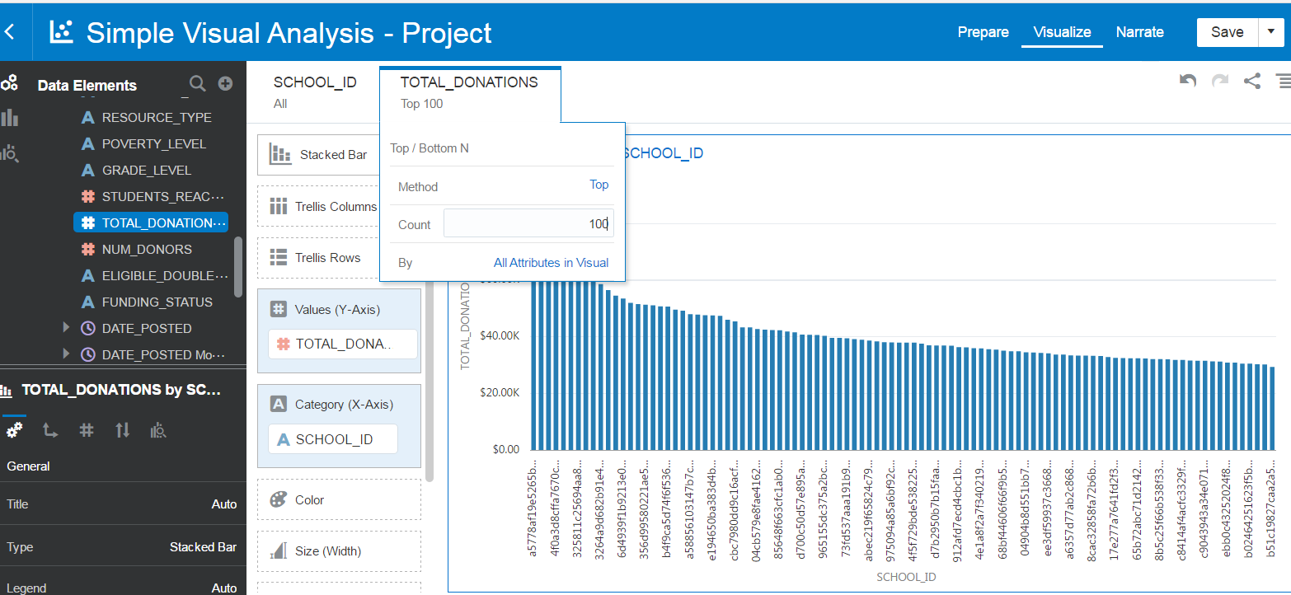

Let's change this viz to a box plot, and show details of teacher in each of these schools

> Change to **Box Plot**

> Select **TEACHER_ACCTID** and Drag to **Detail Box**

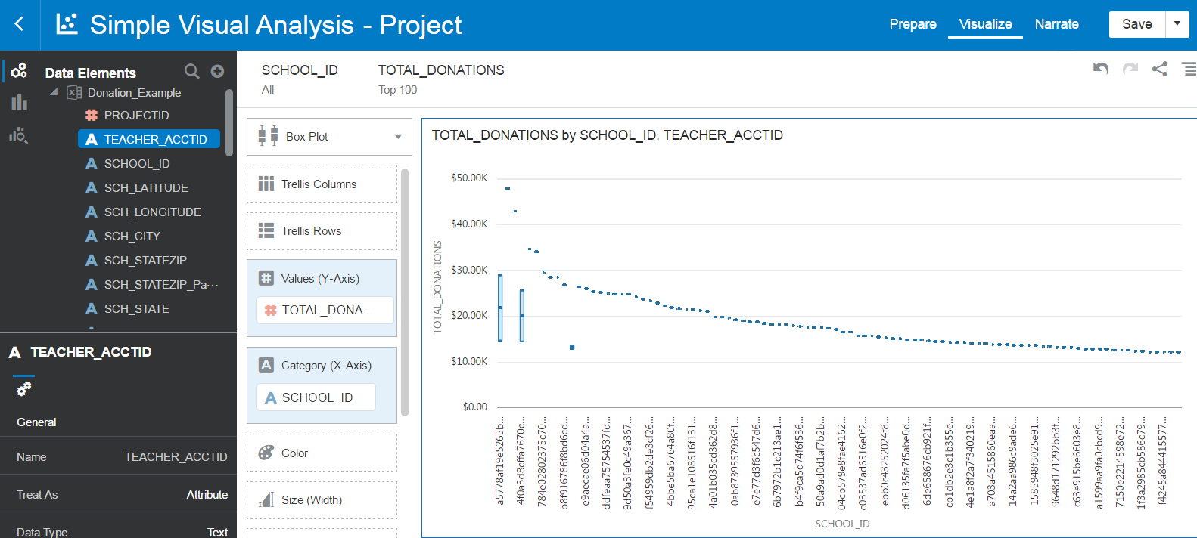

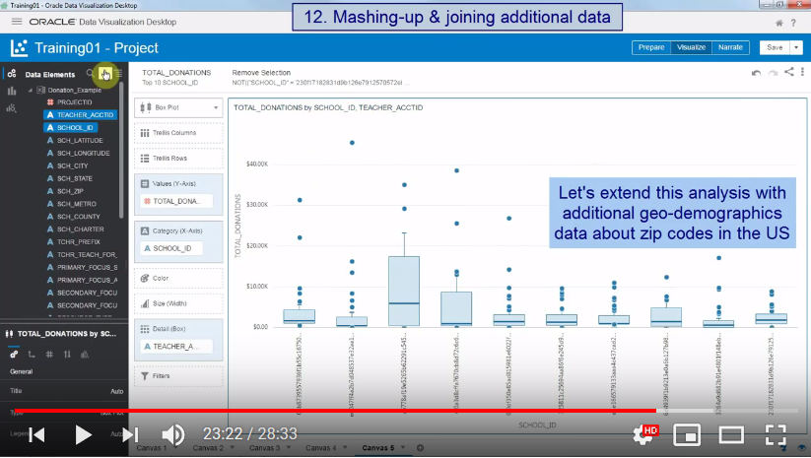

This teacher generates a lot of donations collections, let's filter him out as an outlier

> Remove

# **12. Mashing-up & joining additional data (24:41)**

Let's extend this analysis with additional geo-demographics data about zip codes in the US

We are creating a new datasource using a file that has average income per zip code, and few other metrics

> New Canvas

> **Add Data Set** > **Create Data Set** > From File Zip_Stats.xls

Add

Let's set **Zip** codes to be an **Attribute**, and let's set **Mean** income as **Average** aggregation rule

Add

Let's now join our two datasets using zip code column

> Data diagram

Facts-Facts join as we have metrics in both files...

In DVD 5 join will not work till Attribute have the same Data type (text)

> Add Facts > Ok

**Visualize**

Now let's build a scatter plot joining these two files. Let's see if median income and avg donor donation correlate.

> New canvas

> Drag **Mean, Avg $ per Donor, SCH_ZIP** > Choose **Best Visualization**

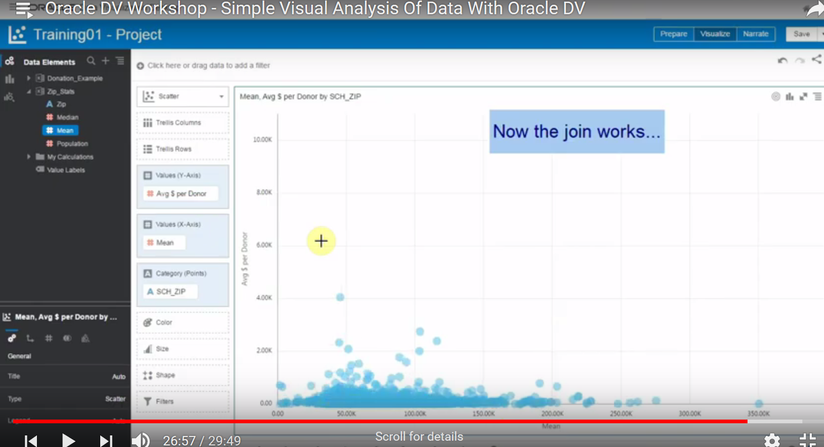

# **13. Viz Specific Aggregations (27:03)**

Let's use a logarithmic Y axis to make this more readable

> **Axis > Vertical Value Axis > Logarithmic Scale On**

> Select **TOTAL_DONATION** and Drag to **Size**

Right click options (reference, trends...) exist for every type of chart

> **Add Reference Line**

**> Add Reference Line**

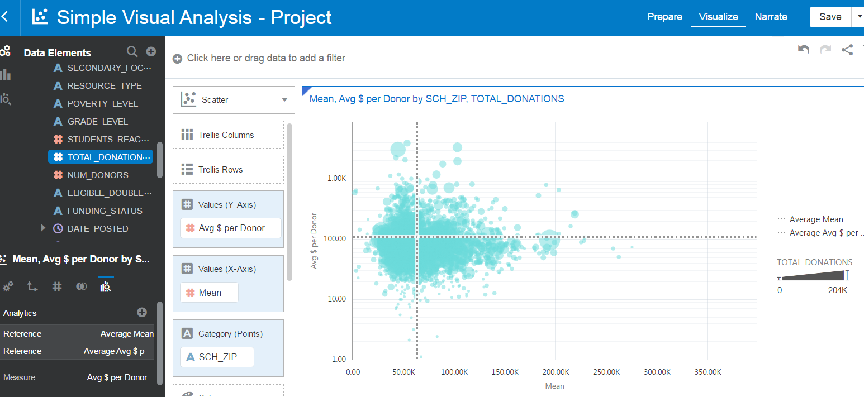

Zip codes are too dense, let's look at cities instead, to make the scatter less busy

> Select **SCH_CITY** and replace **SCH_ZIP** to **Category (Points)**

Problem, both fact tables are not aggregating at the right level (zip/city). We need to set the Mean Income per city to be an average of the zip detail

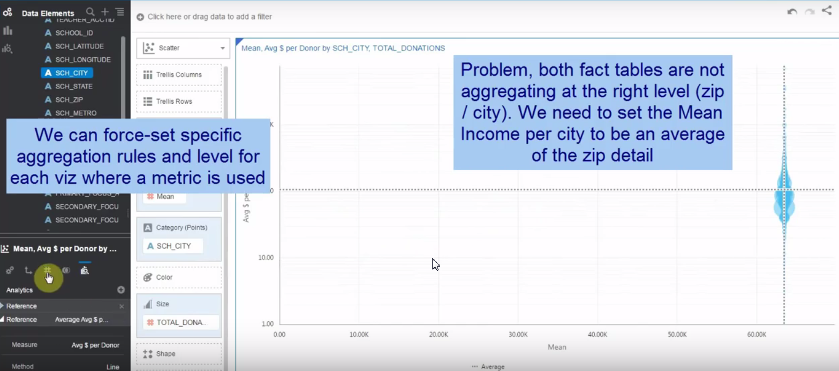

We can force-set specific aggregation rules and level for each viz where a metric is used

> **Values** > **Mean** > **Aggregation Method** > **Average**

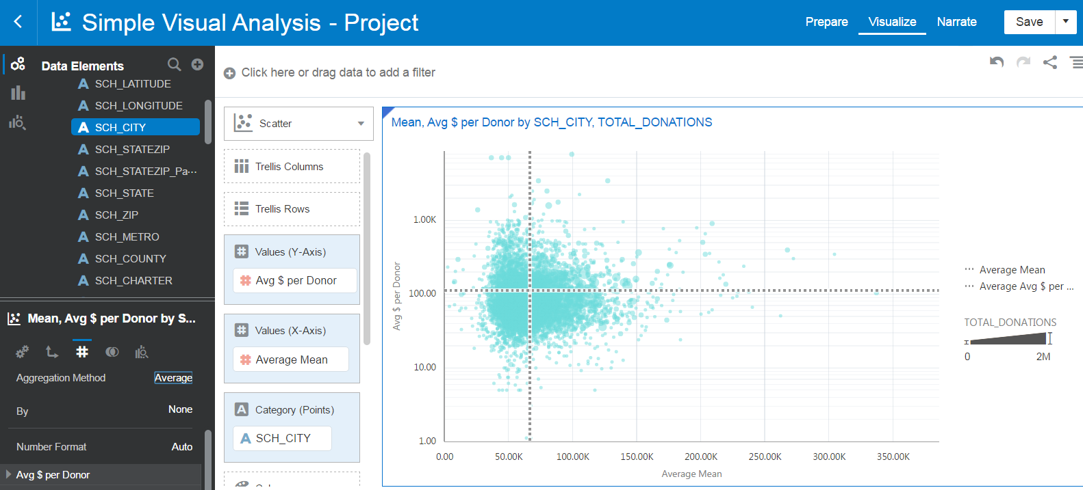

> Select **SCH_COUNTY** and Replace **SCH_CITY** in **Category (Points)**

> **Analytics** > Measure > **Mean** > Function **Median**

Let's add a regression line, to identify an overall relationship

> **Add Trend Line**

> Analytics > Method > **Polynomial**

> Move **TOTAL_DONATION** to **Filter** > **Top Bottom** N 10 / **500**

